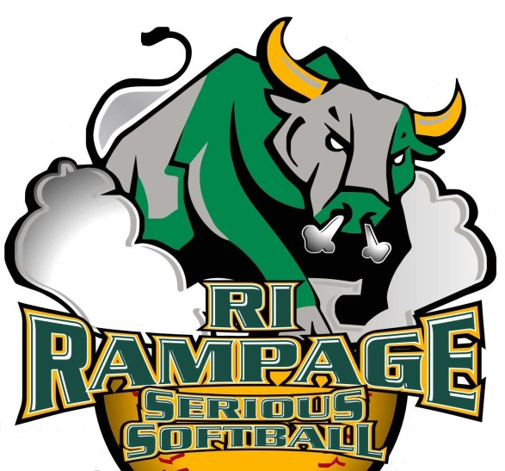
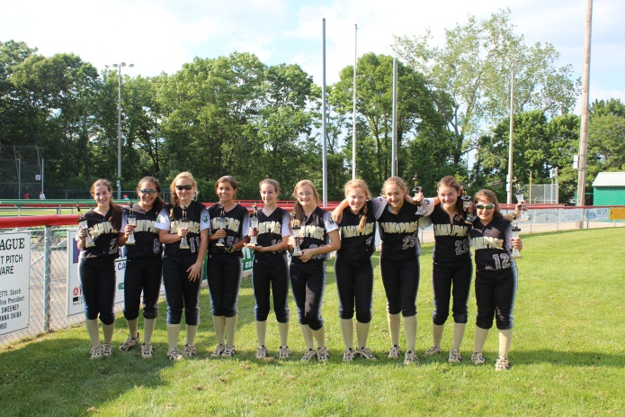
RI Rampage Softball
Fran Clark
6 Leonard Drive
Harrisville, RI 02830

As a valued member of our community, we’d like to ask for your help in providing girls with the opportunity to learn valuable life lessons while participating in competitive softball. The Rampage Fastpitch Softball Association provides players the opportunity to train and play at the highest level, with an emphasis on sportsmanship and integrity. With your help our players can be taught the many life lessons that come with competitive sports, our young ladies will learn responsibility, foster teamwork, be taught how to manage success and disappointment and experience the joys of competition. These lessons learned through sports are lessons that will last a lifetime and are an integral part of developing the complete person.

We are contacting community leaders like you to request financial assistance in the form of a sponsorship. Sponsorship funds are needed to pay for equipment, uniforms, team insurance, training fees, field rentals, and tournament entry fees.

We are offering two sponsorship levels:
□ Silver Sponsor: $250 □ Gold Sponsor: $350

Sponsors will be advertised on the Rampage team banner, displayed at all organizational events, clinics and tournaments. Sponsors will be advertised on the Rampage website with a link to your website if desired. In addition all sponsors will be featured at Serious Softball Indoor Training Facility, www.Serioussoftballri.com.

Can we count on you to help the young ladies of the Rampage Fastpitch Softball Association as a sponsor?

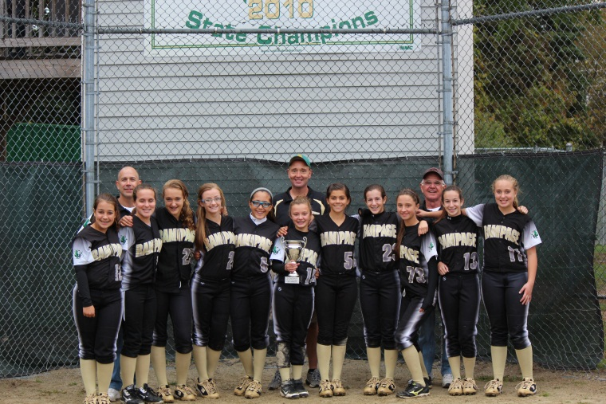
Sponsorship donation $_____________
Company Name:
Address:
Phone Number:
Email:
Contact Person:

Please make checks payable to Rampage Softball and remit to:

Rampage Softball
Fran Clark
6 Leonard Drive
Harrisville, RI 02830 Phone: (401) 301-4567

Thank you very much for your support,

Fran Clark
Rampage Softball WWW.RIRampageSoftball.com

